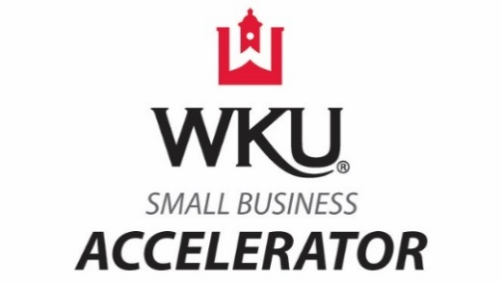
WKU Small Business Accelerator Mentor Network
Mentor Information Form

Date: __________________________________

First and Last Name: ________________________________________
Company Name/Individual: ___________________________________
Address: __________________________________________________________________________________
Phone Number: ____________________________ Email: _________________________________________

How do you prefer to interact with the clients in the Mentor Network?

☐ Email
☐ In-Person Office Visit
☐ Telephone
☐ Teleconference
☐ Text Message
☐ Video Conference

How many hours per month/year are you willing to volunteer to the Mentor Network?

Please identify your area(s) of expertise:

Have you ever been a mentor? ☐ Yes ☐ No

Do you know anyone who may be interested in being a mentor to our clients? If so, please refer them here:

First and Last Name: ______________________________________________
Phone Number: ____________________________ Email: _________________________________________

How did you hear about the WKU Small Business Accelerator Mentor Network?

☐ Referral: ____________________________
☐ Social Media
☐ Newsletter
☐ Other: ____________________________

Thank you for your interest in the WKU Small Business Accelerator Mentor Network! We would like to know how else you may be willing to volunteer to help the clients of our entrepreneurial community.

- Are you willing to provide professional service(s) pro bono or at a discounted rate? ☐ Yes ☐ No
If yes, what service(s) are you willing to provide?

Let us help you! Companies providing professional services pro bono or at a discounted rate will receive free promotion at our entrepreneurial events. Please attach a copy of your logo saved in a JPEG or PNG image file format.

- Are you willing to be a guest speaker at entrepreneurial events? ☐ Yes ☐ No

- Are you willing to present at entrepreneurial workshops? ☐ Yes ☐ No

Please return the completed form to Jeff Hook at william.hook@wku.edu.

